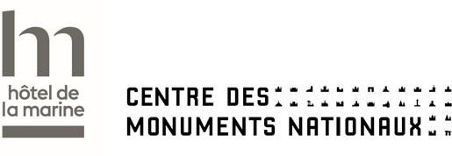
Hôtel de la Marine
2 place de la Concorde 75008 Paris
Email : groupe-hdm@monuments-nationaux.fr

HÔTEL DE LA MARINE – ADULT GROUP

PRE BOOKING FORM

The booking requests must be send at groupe-hdm@monuments-nationaux.fr at least 1 month before your visit

All fields marked with * are mandatory.
Group information

Group/Organization Name*
Type of group
Address
City |  |  |  | Country / State
Phone number
Email
Group leader*
(Surname / Firstname)
Phone number*
Email*
 | Adults  ( + 26 years old, family, affility...) | Tour guide | Association |  | People with disabilities* | Company | Others
Type of group*
Number of guests*

Number of tour leader*

*Do any of the participants have a reduced mobility?
Please feel free to let us know about any specific needs or expectations they may have during the visit.

Choose your tour
When a temporary exhibition does not take place, the Al Thani Collection is closed to the public.
During this time, it is possible to book a visit for the salons and the loggia.
- Audioguided tour with the Confident (audioguide)
- Intendants' Apartments, state Roms and the Loggia

14 euros per person

Duration : 1h15

Please indicate the theme of your visit and the language :

- Voyage dans le temps : History of the Hotel de la Marine from its construction to the present day
Available in French, English, Spanish, Italian, German, Chinese, Japanese, Russian and Arabic

- Siècle des lumières : The Hôtel de la Marine during the 18th century
Available in French and English

- Temporary exhibition of the Al Thani Collection, state rooms and the Loggia
Exhibition « Animalia »

- 11,50 euros per person

- Duration : 1h

Please indicate the language of your visit ( available in French, English and Spanish)

- State rooms and the Loggia - Exhibition « Animalia »

- 7,50 euros per person

- Duration : 30 min

Please indicate the language of your visit ( available in French, English and Spanish)

- Guided tour with a guide of the Hôtel de la Marine*
Available in French, English and Spanish*

- Intendants' Apartments, state Roms and the Loggia
- Guided tour package: €290 + €14 per person (maximum 20 participants)

- Duration: 1h 15 min

- Temporary exhibition of the Al Thani Collection, state rooms and the Loggia - Exhibition « Animalia »
- Guided tour package: €250 + €11.50 per person (maximum 20 participants)
- Duration: 1 h 15 min

*Please indicate the language of your visit

- Guided tour with your own tour guide

- Intendants' Apartments, state Roms and the Loggia

14 euros per person

Duration : 1h15 min

Free admission for the tour guide

- Temporary exhibition of the Al Thani Collection, state rooms and the Loggia Exhibition « Animalia »

11,50 euros per person

Duration : 1h15 min

free admission for the tour guide

Choose the day and time of your visit

Preferred date* (Please Indicate 3 choices max)
Preferred time* (Please Indicate 3 choices max)

Additional information

Do not hesitate to indicate any necessary informations or exceptations regarding the members of your group during the visit

